**Exploring NPM (Node Package Manager)**

**Assignment**



Session: 2021 – 2024

**Submitted by:**

Uswa Arif

2021-CS-77

**Submitted To:**

  Aatif Hussain

Department of Computer Science

**University of Engineering and Technology**

**Lahore Pakistan**

**Node.js and NPM:**

Node.js is an open source server environment in which projects are created and executed. NPM is a package manager for Node.js packages and modules. The packages used in Node.js projects are downloaded through npm.

**Assignment Overview:**

The assignment involved converting SCSS code to CSS using Webpack. Webpack was chosen for its powerful bundling and asset management capabilities.

**Node.js and NPM Installation:**

**Node.js Installation:**

* Open the official website of Node.js.
* Download the LTS (Long Term Support) version for Windows.
* A file will be downloaded then install it on your system.

**NPM Installation:**

* NPM will be downloaded with the Node.js.

**Basic NPM Commands:**

1. **Check NPM Version:**

npm -v

1. **Initialize a New Project:**

npm init -y

1. **Install Package:**

npm install package-name

1. **List of Installed Packages:**

npm list

1. **Uninstall a Package:**

npm uninstall package-name

1. **Build the Code at server for the first time:**

npm run build

1. **Run the Code at server:**

npm run start

**Advanced NPM Commands:**

Webpack Package is used to used to convert the SCSS code into CSS and installs different loaders like html-loader, style-loader, image-loaders and different plugins like to add images to your website using SCSS. The commands used to add Webpack in your Node project, are:

1. **Install Webpack:**

npm install webpack webpack-cli --save-dev

1. **Install Webpack Dev Server:**

This command is used to run your project to the Local Host Server and if you make the changes to the project then there is no need for manually refresh the page, changes will appear automatically. The command is:

**“npm install webpack-dev-server --save-dev”**

1. **Install Webpack Plugins:**

The plugins used in Webpack Package can be installed by using command:

**“npm install webpack-plugin-name --save-dev”**

The Plugin I have used in my project is **Copy-Webpack-Plugin**. This plugin is used to copy the images from the src folder images to the output directory dist. The folder images also created in **dist** folder that is the output folder from where the images will load to the executing website. This plugin will be use when you are writing code to add images to the HTML file and SCSS file. Then, this plugin add images to the output directory. The command is:

**“npm install copy-webpack-plugin --save-dev”**

1. **Run Webpack in Development Mode:**

When you are in development phase like you are developing the website and you want to run the project, then you will set the mode of the webpack to the Development. The command used for it is:

**“webpack --mode development”**

1. **Run Webpack in Production Mode:**

When you are in Production mode like you have completed the project, then you will set the mode of the webpack to the Production and command used for it is:

**“webpack --mode production”**

1. **Watch for changes and Automatically Rebuild:**

The command used to automatically build the changes and not again use the command to build the project is:

**“webpack –watch”**

1. **Run website on Server:**

To use Webpack Dev Server (run website on local server), the command that is used:

**“npx webpack serve”**

This command will start the server and you can access the project at:

“**http://localhost:8080”**

**Management of Dependencies:**

1. **Dependency Installation:**

The command used for it is:

“npm install dependency-name”

1. **Save Dependency to Package.json:**

The command used for it is:

“npm install dependency-name –save”

**Creation and Publication of NPM Package:**

**Create a Package:**

1. Organize your project structure.
2. Create a “package.json” file with necessary details.

**Publishing a Package:**

1. Create an account on the npm website.
2. Login to npm using command “npm login”.
3. Run command “npm publish” to publish your package.

**Challenges Faced:**

1. **Image Path Issues:**

The challenges faced due to incorrect image paths in SCSS. This was resolved by adding the images folder in the same folder in which SCSS file was present and then adding the images to the output directory of “**dist**”.

1. **Webpack Configuration:**

The configuration file of Webpack that was “**webpack.config.js**” was adjusted according to the SCSS conversion. The modules, mode phase and entry points were configured to handle SCSS files. The path defined in this file was also very difficult to handle.

1. **Image Loader Package:**

This package is used to load the images to the output directory and it has many issues with image loading and these issues was difficult to handle so I use plugin of “**Copy-Webpack-Plugin**” instead of this package.

**Implementation:**

1. Created npm project.

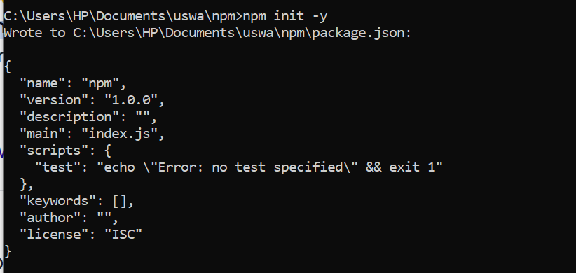

1. Installed webpack package and necessary loaders like html-loader, style loader, sass loader and image-loader.

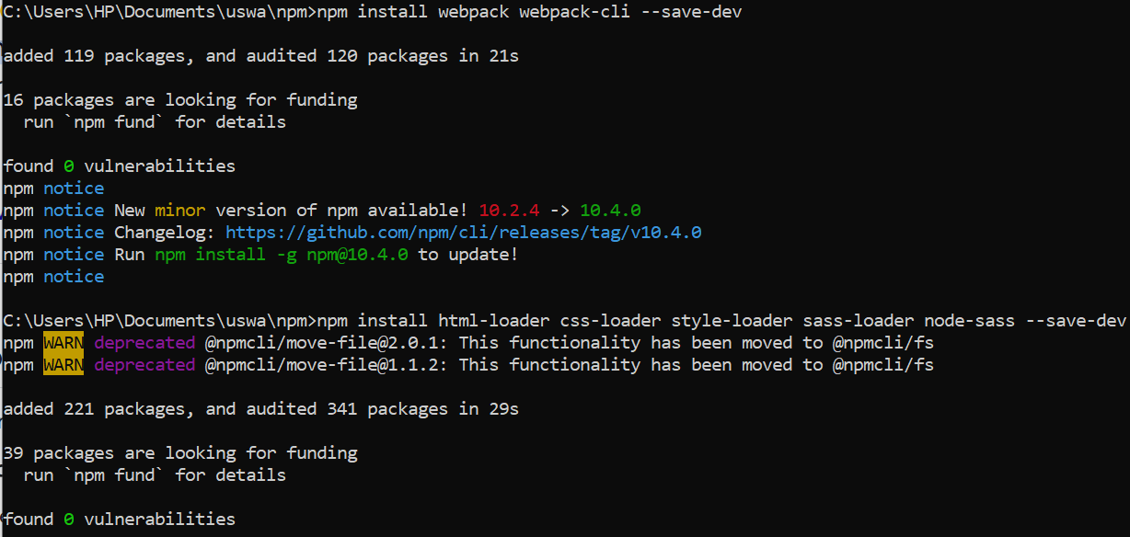

1. Created index.html file.

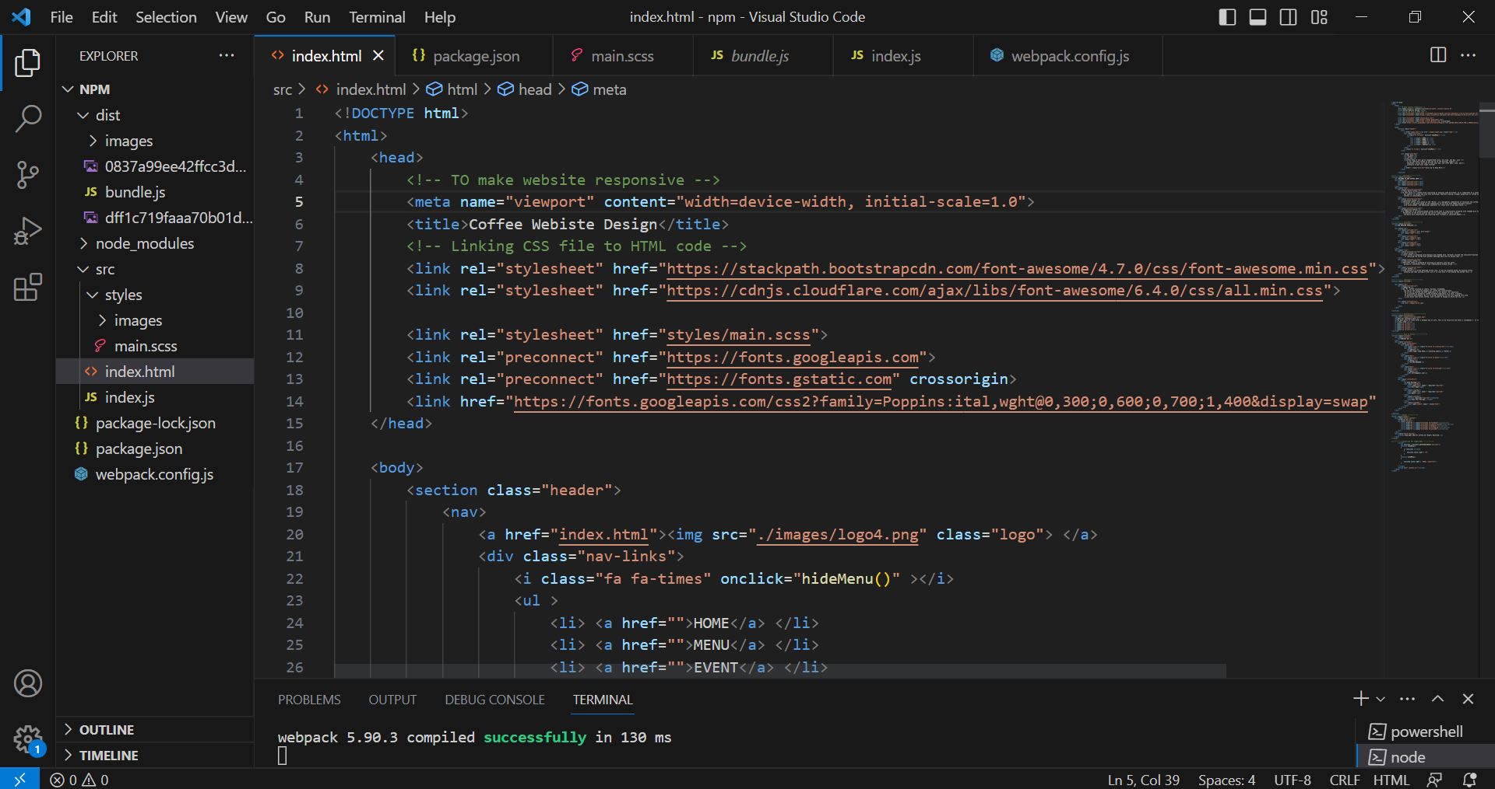

1. Created “**src/styles/main.scss**” file.

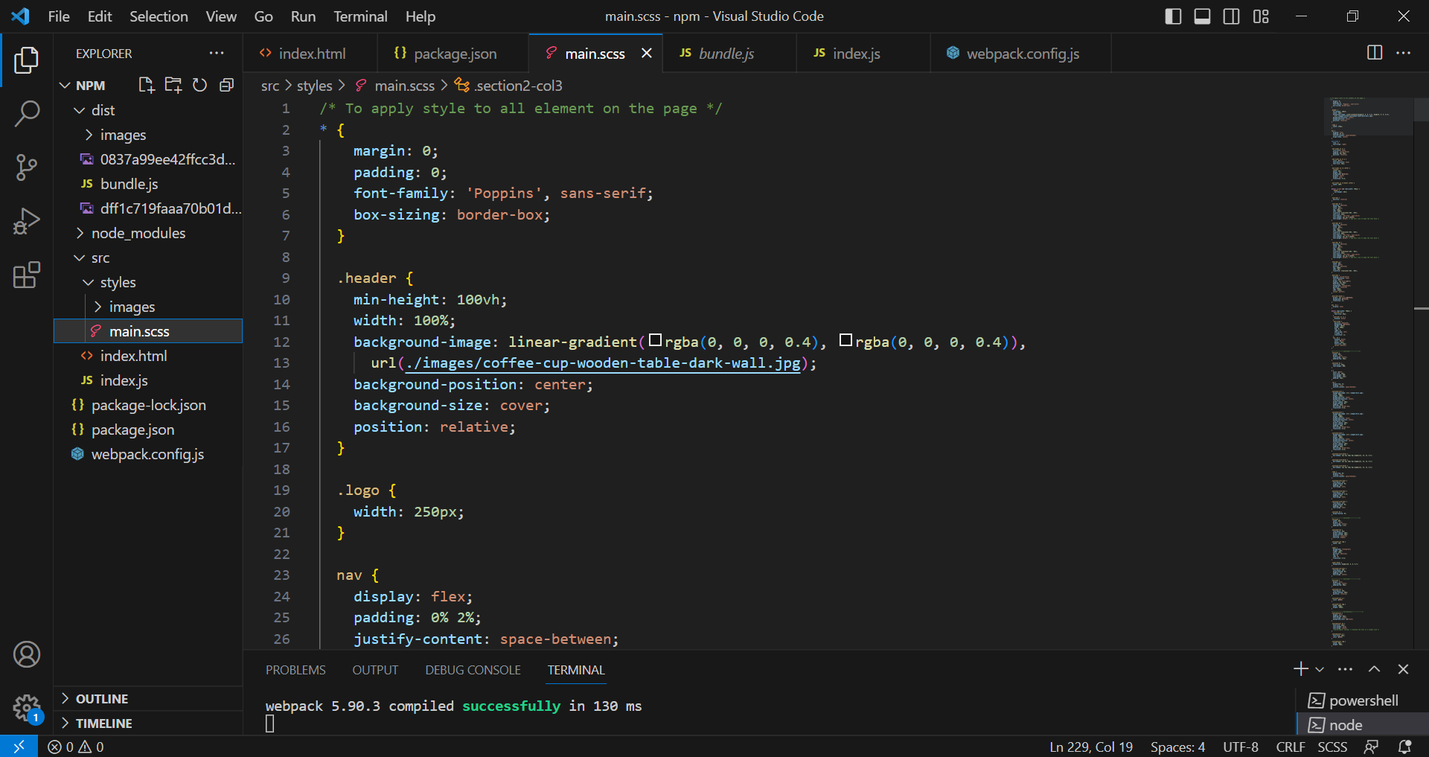

1. Created “**src/index.js**” file and imported the scss file path to it.

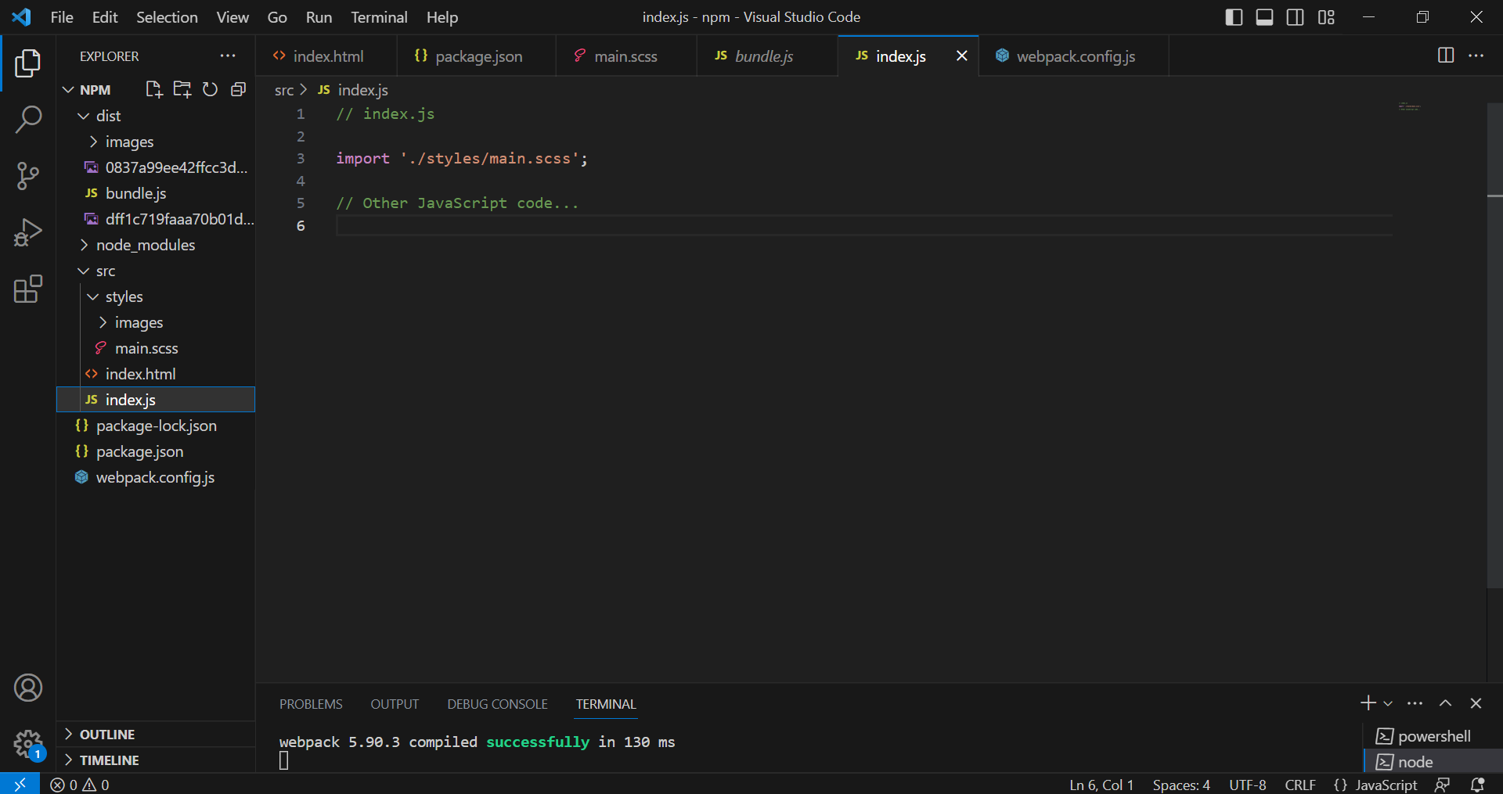

1. Configured webpack by creating file “**webpack.config.js**”. Set the mode to “**development**” as given in following image. Added module to copy images to output directory.

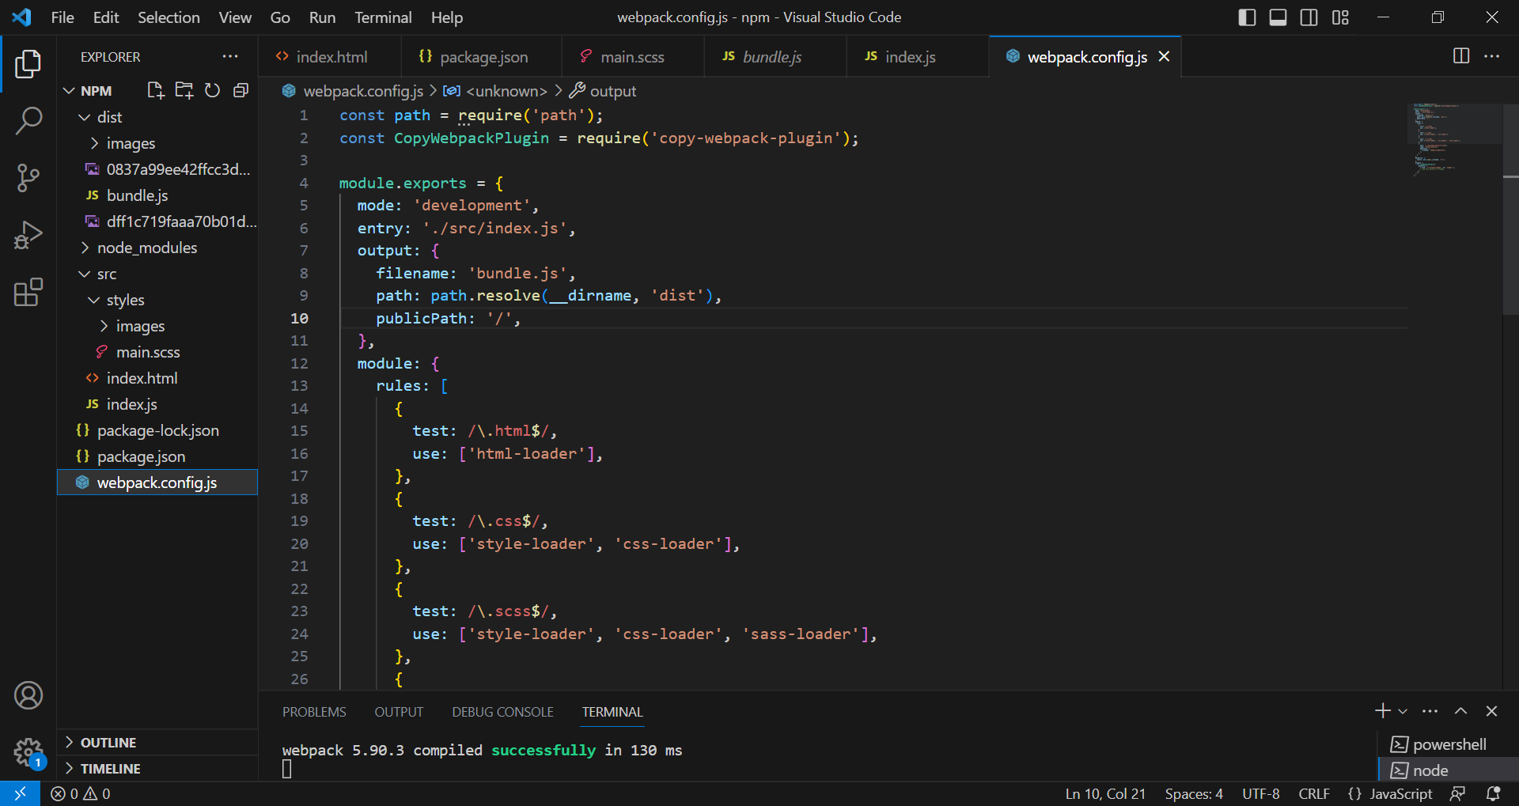

Added “**devServer**” to the webpack.config.js file.

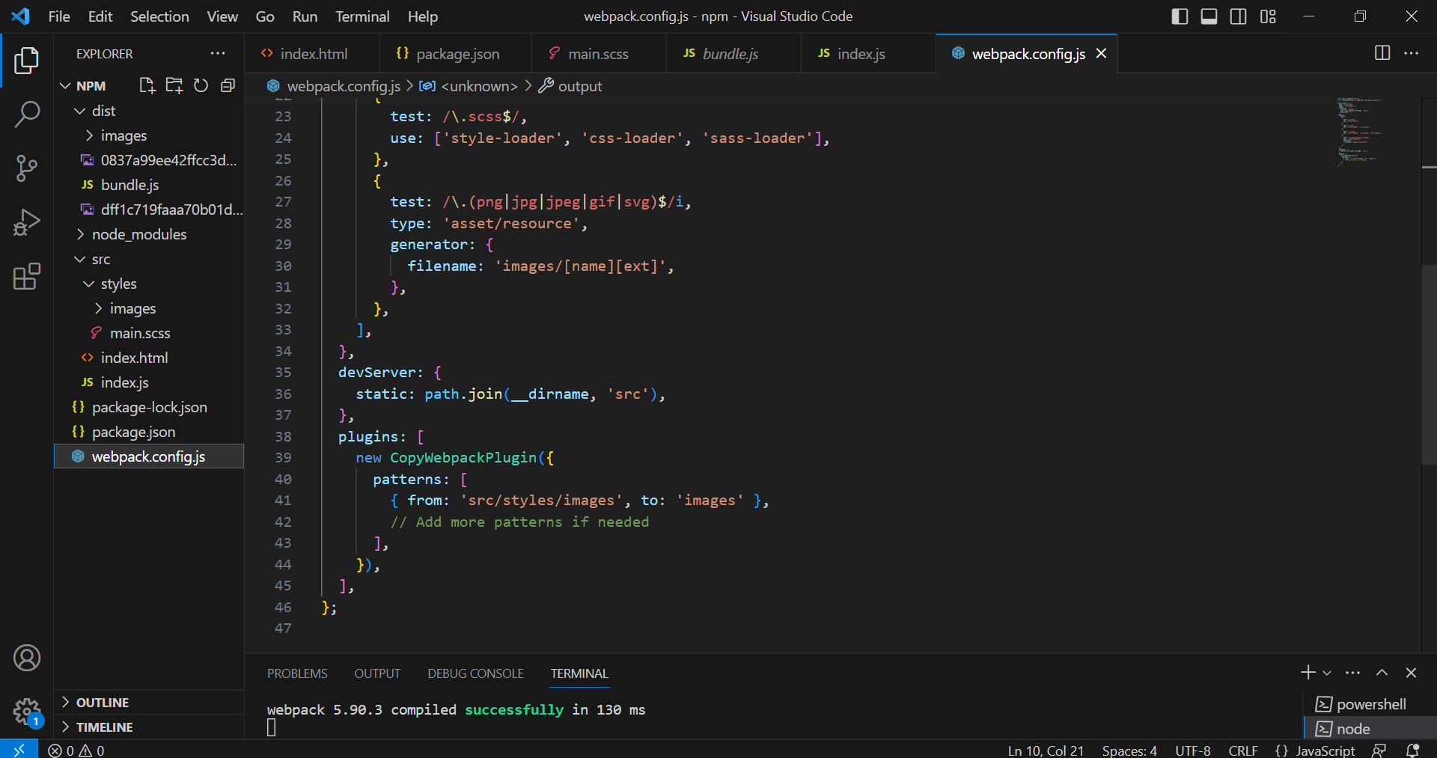

1. Added **bundle.js file** reference in the html file.

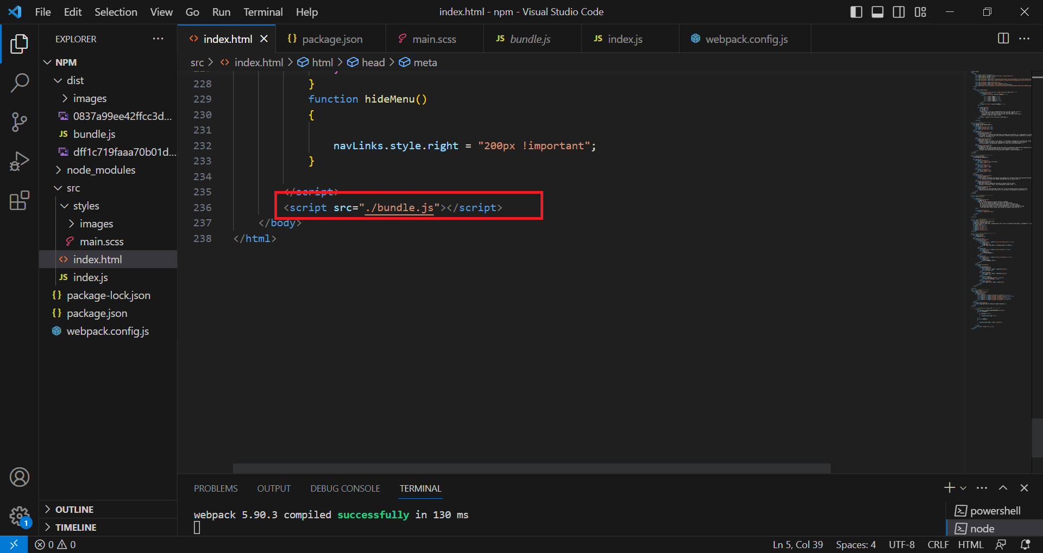

1. To add html images to the output directory, downloaded the plugin named “Copy-webpack-Plugin” and then added the plugin in webpack.config.js file as given the webpage. Config.js code above.
2. Ran the command to build the project. The command is “**npm run build**”.
3. After running this command, the files that created automatically in to project folder are: dist(output directory), bundle.js file.

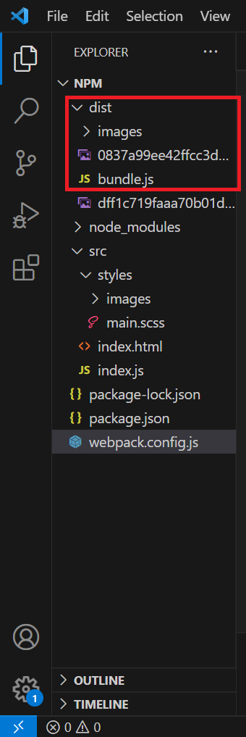

1. Then at last to run the code on server, wrote the command “**npx webpack server**”, then open the localhost on chrome ‘http://localhost:8080/’ and code runs on the local host.
2. The Website running screenshot is:

